A Project Report On

**ABHIVYAKTI WEBSITE**

Submitted in partial fulfillment of the requirement for the award of the degree

MASTER OF COMPUTER APPLICATIONS (INTEGRATED)

from

Gujarat Technological University



Academic Year 2020 – 2021

**Mansi Gusani (175220686016)**

|  |
| --- |
| Internal Guide |
| **Dr. Sunil Bajeja** |



Marwadi Education Foundation’s Group of Institutions

(MEFGI)

Rajkot-Morbi Road, At & PO : Gauridad, Rajkot 360 003. Gujarat. India.



Faculty of Computer Applications (FCA)



This is to certify that the project work entitled

**ABHIVYAKTI WEBSITE**

submitted in partial fulfillment of the requirement for

the award of the degree of

Master of Computer Applications (Integrated)

of the

Gujarat Technological University

is a result of the bonafide work carried out by

**Mansi Gusani (175220686016)**

during the academic year 2020 – 2021

|  |  |  |  |  |
| --- | --- | --- | --- | --- |
| Faculty Guide |  |  | HOD |  |

External Viva

|  |  |  |
| --- | --- | --- |
| Name of the Examiners |  | Signature with Date |

**CERTIFICATE**

**DECLARATION**

I hereby declare that this project work entitled **ABHIVYAKTI WEBSITE** is a record done by me.

I also declare that the matter embodied in this project is genuine work done by me and has not been submitted whether to this University or to any other University / Institute for the fulfillment of the requirement of any course of study.

Place:

Date:

**Mansi Gusani (175220686016) Signature:**

**ACKNOWLEDGEMENT**

It is indeed a great pleasure to express my thanks and gratitude to all those who helped me. No serious and lasting achievement or success one can ever achieve without the help of friendly guidance and co-operation of so many people involved in the work.

I am very thankful to my guide **Dr. Sunil Bajeja,** the person who makes me to follow the right steps during a project work. I express my deep sense of gratitude to him for his guidance, suggestions and expertise at every stage. A part from that his valuable and expertise suggestion during documentation of my report indeed help me a lot.

Thanks to my friends and colleagues who have been a source of inspiration and motivation that helped to me during my project work.

I would heartily thankful to my Dean **Dr. R. Sridaran** and Head of Department **Dr. Sunil Bajeja** to give me an opportunity to work over this report and for their end-less and great support. And to all other people who directly or indirectly supported and help me to fulfil my task.

**Mansi Gusani (175220686016) Signature:**

**CONTENTS**

|  |  |  |
| --- | --- | --- |
| **Chapters** | **Particulars** | **Page No.** |
| **1** | **SYNOPSIS** | 1 |
| **2**  2.1  2.2 | **PREAMBLE**  Project Description  Modules And Description | 2  3 |
| **3**  3.1  3.2 | **TECHNICAL DESCRIPTION**  Software Requirements  Hardware Requirements | 4  4 |
| **4**  4.1  4.2  4.3  4.4  4.5 | **SYSTEM DESIGN AND DEVELOPMENT**  Use Case Diagram  Sequence Diagram  Class Diagram  Activity Diagram  File Structure With Description | 5  6-7  8  9  10-17 |
| **5**  5.1  5.2 | **SYSTEM TESTING**  Testing Methodologies  Validation Checking | 18  19-21 |
| **6** | **SCREENSHOTS** | 22-39 |
| **7** | **SOURCE CODE** | 40-54 |
| **8** | **CONCLUSION** | 55 |
| **9**  9.1  9.2 | **BIBLIOGRAPHY**  Online References  Offline References | 56  56 |

**FIGURE INDEX**

|  |  |  |  |
| --- | --- | --- | --- |
| **Sr. No.** | **Figure No.** | **Particulars** | **Page No.** |
| 1. | 4.1 | Use Case Diagram | 5 |
| 2. | 4.2.1 | Set The Profile | 6 |
| 3. | 4.2.2 | Write Or Publish The Content | 7 |
| 4. | 4.3 | Class Diagram | 8 |
| 5. | 4.4 | Activity Diagram | 9 |
| 6. | 6.1 | Index Page | 22 |
| 7. | 6.2 | About Us | 23 |
| 8. | 6.3 | Index Page – 1 | 24 |
| 9. | 6.4 | Index Page – 2 | 24 |
| 10. | 6.5 | Index Page – 3 | 25 |
| 11. | 6.6 | Google Sign-In – 1 | 25 |
| 12. | 6.7 | Google Sign-In – 2 | 26 |
| 13. | 6.8 | Home Page – 1 | 26 |
| 14. | 6.9 | Home Page – 2 | 27 |
| 15. | 6.10 | Home Page – 3 | 27 |
| 16. | 6.11 | Categories – 1 | 28 |
| 17. | 6.12 | Categories – 2 | 28 |
| 18. | 6.13 | Categories – 3 | 29 |
| 19. | 6.14 | Write – 1 | 29 |
| 20. | 6.15 | Write – 2 | 30 |
| 21. | 6.16 | Write – 3 | 30 |
| 22. | 6.17 | Update – 1 | 31 |
| 23. | 6.18 | Update – 2 | 31 |
| 24. | 6.19 | Update – 3 | 32 |
| 25. | 6.20 | User Profile – 1 | 32 |
| 26. | 6.21 | User Profile – 2 | 33 |
| 27. | 6.22 | User Profile – 3 | 33 |
| 28. | 6.23 | Library – 1 | 34 |
| 29. | 6.24 | Library – 2 | 34 |
| 30. | 6.25 | Library – 3 | 35 |
| 31. | 6.26 | Followers – 1 | 35 |
| 32. | 6.27 | Followers – 2 | 36 |
| 33. | 6.28 | Followers – 3 | 36 |
| 34. | 6.29 | Following – 1 | 37 |
| 35. | 6.30 | Following – 2 | 37 |
| 36. | 6.31 | Following – 3 | 38 |
| 37. | 6.32 | Review Report – 1 | 38 |
| 38. | 6.33 | Review Report – 2 | 39 |
| 39. | 6.34 | Review Report – 3 | 39 |

**TABLE INDEX**

|  |  |  |  |
| --- | --- | --- | --- |
| **Sr. No.** | **Table No.** | **Particulars** | **Page No.** |
| 1. | 3.1 | Software Requirements | 4 |
| 2. | 3.2 | Hardware Requirements | 4 |
| 3. | 4.5.1 | Users Table | 10 |
| 4. | 4.5.2 | Profile Table | 11 |
| 5. | 4.5.3 | Write_Content Table | 12 |
| 6. | 4.5.4 | RateReview Table | 13 |
| 7. | 4.5.5 | Library Table | 14 |
| 8. | 4.5.6 | FollowersFollowing Table | 15 |
| 9. | 4.5.7 | Update1 Table | 16 |
| 10. | 4.5.8 | Discuss Table | 17 |
| 11. | 5.1 | Testing Methodologies | 18 |
| 12. | 5.2.1 | Test Case – 1 [Gmail ID] | 19 |
| 13. | 5.2.2 | Test Case – 2 [Password] | 19 |
| 14. | 5.2.3 | Test Case – 3 [Upload Profile Image] | 19 |
| 15. | 5.2.4 | Test Case – 4 [Name Field] | 19 |
| 16. | 5.2.5 | Test Case – 5 [Birthdate Field] | 20 |
| 17. | 5.2.6 | Test Case – 6 [Phone No. Field] | 20 |
| 18. | 5.2.7 | Test Case – 7 [Choose The Category] | 20 |
| 19. | 5.2.8 | Test Case – 8 [Title Field] | 20 |
| 20. | 5.2.9 | Test Case – 9 [Upload The File] | 20 |
| 21. | 5.2.10 | Test Case – 10 [Upload Content Image] | 21 |
| 22. | 5.2.11 | Test Case – 11 [Rating Field] | 21 |
| 23. | 5.2.12 | Test Case – 12 [Review Field] | 21 |
| 24. | 5.2.13 | Test Case – 13 [Review Field] | 21 |

**Chapter 1**

**SYNOPSIS**

Abhivyakti is a website, which provides self-publishing and reading platform to the writers and the readers. Its features and functionality are provided in 3 languages: Gujarati, Hindi and English. It allows users to publish and read original works such as stories, poetries, articles, essays, etc… It also allows readers to rate and to comment content posted by the others.

Through the Gmail Account multiple users can communicate with this website and they can share their ideas, greetings, suggestions with this website and the other users on this platform. This website provides good interface and connectivity to users. It is user friendly website and more convenient for the users.

**1**

**Chapter 2**

**PREAMBLE**

**2.1 Project Description:**

In this project, I have used PHP, HTML, CSS, JQUERY, AJAX and JAVA Script for creating attractive, more efficient, and extra ordinary website, and also I have used MySQL to create and manage the database. For creating logo and images, I have used Photoshop.

This project is designed with the goal of making the existing site more informative, reliable and secure for that users have to login in this site with valid Gmail ID and Password, then and then users are able to use this site for the various purposes such as creating profile, publishing contents, reading contents, participating in various competitions, etc…

I do my best to protect user’s privacy details and I make sure that I will not share any personally identifiable information with any third party. And the data transactions on the website are also secured.

In short, this is a great opportunity for transcript and a great platform for all people, from the perspective of writing to the world of reading-writing.

**2**

**2.2 Modules And Description:**

There are mainly 6 modules which are included in this project: Home, Write, Search, Categories, Update and Profile.

1. **Home:**

It is a front layout of the website, which is connected with all the pages of different modules.

1. **Write:**

Writer can publish any content with the help of this module by following easy steps.

1. **Search:**

To find any content or author’s or poet’s name, this module is used.

1. **Categories:**

This module provides many classifications of the different contents: Suspense and Thriller, Romantic, Horror, Funny, Spiritual, Social, etc… Stories, Science Fiction, Child Literature, Woman Special, Article, Poems, Film and Music, Biography, Travel and Tourism, Essay, and Other Stories, etc… Due to these classifications, readers can easily get any require content.

1. **Update:**

This module is used to display notifications and messages.

1. **Profile:**

This module is created to set personal information, maintain library, to keep the record of followers and following, to know the total reviews and rating.

**3**

**Chapter 3**

**TECHNICAL DESCRIPTION**

**3.1 Software Requirements:**

|  |
| --- |
| **Minimum Software Requirements** |
| Microsoft Windows 98, 7, Vista Or Higher Operating System |
| Google Chrome, Mozilla Firefox, Microsoft Edge |
| Any Editor (i.e. Notepad++, Notepad,…) |
| PHP 7.3.1 |
| phpMyAdmin 4.9.1 |
| Apache 2.4.41 |

**3.2 Hardware Requirements:**

|  |
| --- |
| **Minimum Hardware Requirements** |
| 512 MB RAM |
| Intel Pentium III Or Higher Processor |
| HDD 90 GB Or Higher |

**4**

**Chapter 4**

**SYSTEM DESIGN AND DEVELOPMENT**

**4.1 Use Case Diagram:**

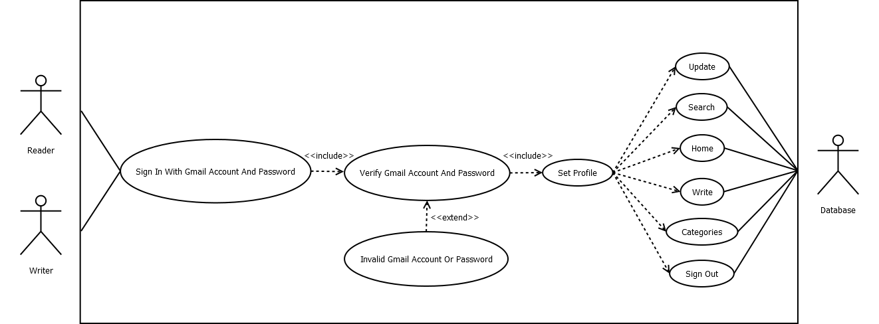

**5**

**4.2 Sequence Diagram:**

**4.2.1 Set The Profile:**

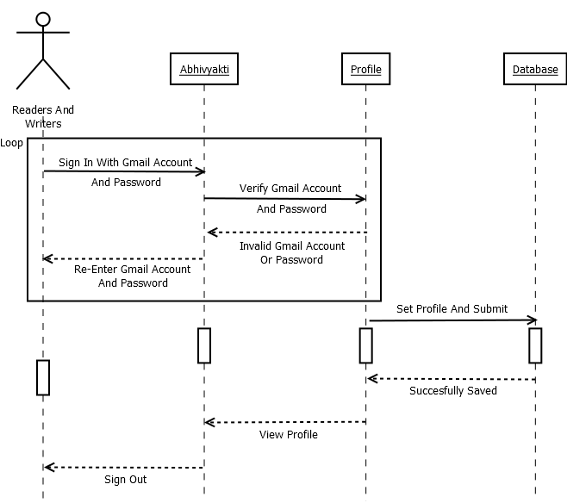

**6**

**4.2.2 Write Or Publish The Content:**

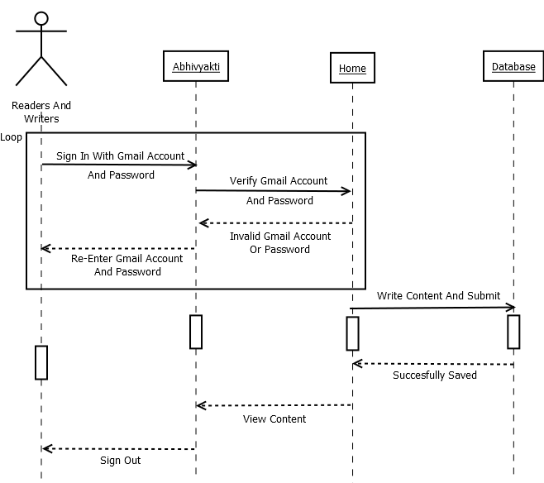

**7**

**4.3 Class Diagram:**

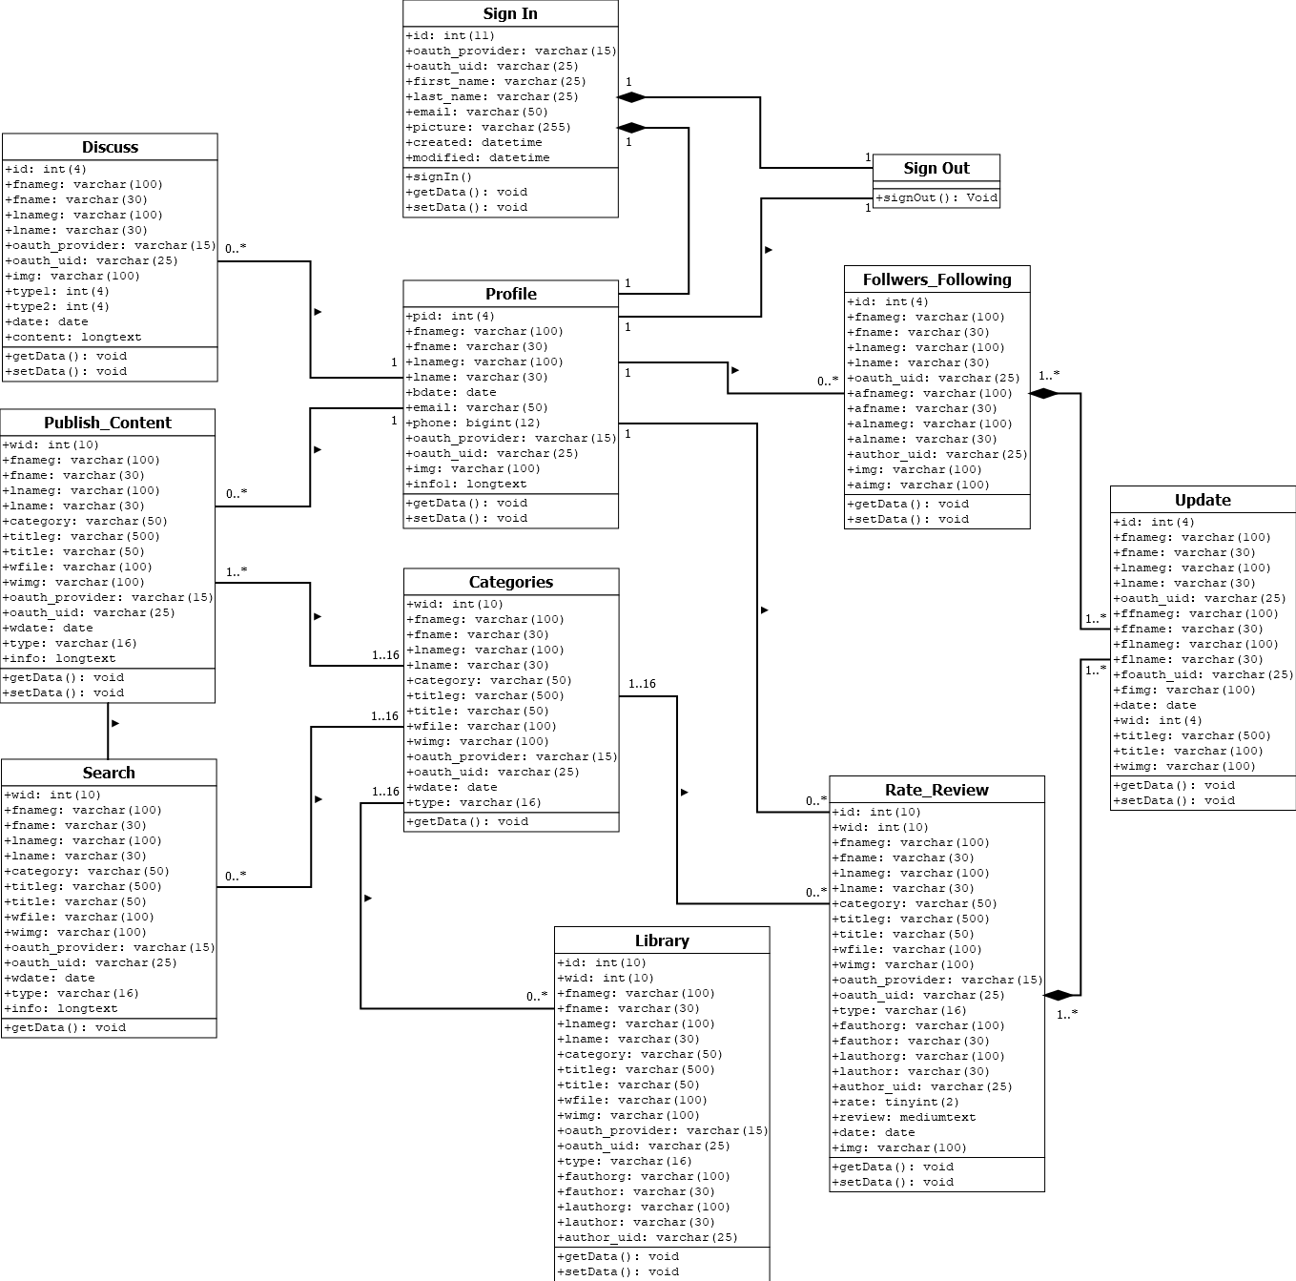

**8**

**4.4 Activity Diagram:**

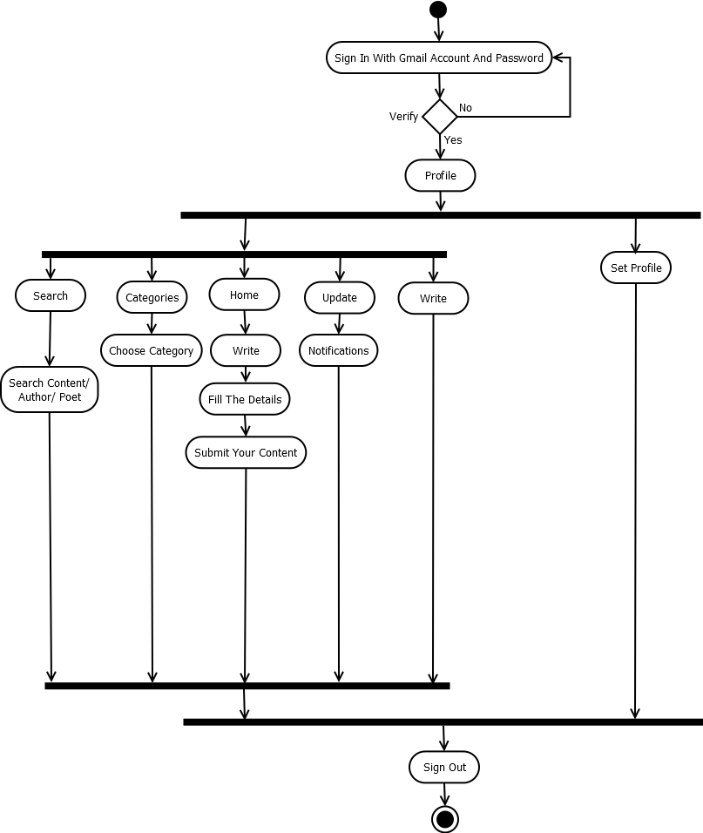

**9**

**4.5 File Structure With Description:**

**4.5.1 Users Table:**

|  |  |  |  |  |  |
| --- | --- | --- | --- | --- | --- |
| **Sr. No.** | **Column Name** | **Data Type** | **Size** | **Constraint** | **Description** |
| 1. | id | int | 11 | Auto Increment | Primary Key |
| 2. | oauth_provider | varchar | 15 | NOT NULL | Google |
| 3. | oauth_uid | varchar | 25 | NOT NULL | Google ID |
| 4. | first_name | varchar | 25 | NOT NULL | First Name |
| 5. | last_name | varchar | 25 | NOT NULL | Last Name |
| 6. | email | varchar | 50 | NOT NULL | Email |
| 7. | picture | varchar | 255 | NOT NULL | Image |
| 8. | created | datetime | - | NOT NULL | Created Date |
| 9. | modified | datetime | - | NOT NULL | Created Date |

**10**

**4.5.2 Profile Table:**

|  |  |  |  |  |  |
| --- | --- | --- | --- | --- | --- |
| **Sr. No.** | **Column Name** | **Data Type** | **Size** | **Constraint** | **Description** |
| 1. | pid | Int | 4 | Auto Increment | Primary Key |
| 2. | fnameg | Varchar | 100 | NOT NULL | First Name [G] |
| 3. | fname | Varchar | 30 | NOT NULL | First Name |
| 4. | lnameg | Varchar | 100 | NOT NULL | Last Name [G] |
| 5. | lname | Varchar | 30 | NOT NULL | Last Name |
| 6. | bdate | Date | - | NOT NULL | Birthdate |
| 7. | email | Varchar | 50 | NOT NULL | Email |
| 8. | phone | Bigint | 12 | NOT NULL | Phone No. |
| 9. | oauth_provider | Varchar | 15 | NOT NULL | Google |
| 10. | oauth_uid | Varchar | 25 | NOT NULL | Google ID |
| 11. | img | Varchar | 100 | NOT NULL | Image |
| 12. | info1 | Longtext | - | NOT NULL | Text |

**11**

**4.5.3 Write_Content Table:**

|  |  |  |  |  |  |
| --- | --- | --- | --- | --- | --- |
| **Sr. No.** | **Column Name** | **Data Type** | **Size** | **Constraint** | **Description** |
| 1. | Wid | int | 10 | Auto Increment | Primary Key |
| 2. | Fnameg | varchar | 100 | NOT NULL | First Name [G] |
| 3. | Fname | varchar | 30 | NOT NULL | First Name |
| 4. | Lnameg | varchar | 100 | NOT NULL | Last Name [G] |
| 5. | Lname | varchar | 30 | NOT NULL | Last Name |
| 6. | Category | varchar | 50 | NOT NULL | Category |
| 7. | Titleg | varchar | 500 | NOT NULL | Title [G] |
| 8. | Title | varchar | 50 | NOT NULL | Title |
| 9. | Wfile | varchar | 100 | NOT NULL | File Name |
| 10. | Wimg | varchar | 100 | NOT NULL | File Image |
| 11. | oauth_provider | varchar | 15 | NOT NULL | Google |
| 12. | oauth_uid | varchar | 25 | NOT NULL | Google ID |
| 13. | Wdate | date | - | NOT NULL | Date |
| 14. | Type | varchar | 16 | NOT NULL | Type |
| 15. | Info | longtext | - | NOT NULL | Text |

**12**

**4.5.4 RateReview Table:**

|  |  |  |  |  |  |
| --- | --- | --- | --- | --- | --- |
| **Sr. No.** | **Column Name** | **Data Type** | **Size** | **Constraint** | **Description** |
| 1. | id | int | 10 | Auto Increment | Primary Key |
| 2. | wid | int | 10 | NOT NULL | ID |
| 3. | fnameg | varchar | 100 | NOT NULL | First Name [G] |
| 4. | fname | varchar | 30 | NOT NULL | First Name |
| 5. | lnameg | varchar | 100 | NOT NULL | Last Name [G] |
| 6. | lname | varchar | 30 | NOT NULL | Last Name |
| 7. | category | varchar | 50 | NOT NULL | Category |
| 8. | titleg | varchar | 500 | NOT NULL | Title [G] |
| 9. | title | varchar | 50 | NOT NULL | Title |
| 10. | wfile | varchar | 100 | NOT NULL | File Name |
| 11. | wimg | varchar | 100 | NOT NULL | File Image |
| 12. | oauth_provider | varchar | 15 | NOT NULL | Google |
| 13. | oauth_uid | varchar | 25 | NOT NULL | Google ID |
| 14. | type | varchar | 16 | NOT NULL | Type |
| 15. | fauthorg | varchar | 100 | NOT NULL | Author First Name [G] |
| 16. | fauthor | varchar | 30 | NOT NULL | Author First Name |
| 17. | lauthorg | varchar | 100 | NOT NULL | Author Last Name [G] |
| 18. | lauthor | varchar | 30 | NOT NULL | Author Last Name |
| 19. | author_uid | varchar | 25 | NOT NULL | Author Google ID |
| 20. | rate | tinyint | 2 | NOT NULL | Rate |
| 21. | review | mediumtext | - | NOT NULL | Review |
| 22. | date | date | - | NOT NULL | Date |
| 23. | img | varchar | 100 | NOT NULL | Image |

**13**

**4.5.5 Library Table:**

|  |  |  |  |  |  |
| --- | --- | --- | --- | --- | --- |
| **Sr. No.** | **Column Name** | **Data Type** | **Size** | **Constraint** | **Description** |
| 1. | id | int(10) | 10 | Auto Increment | Primary Key |
| 2. | wid | int(10) | 10 | NOT NULL | ID |
| 3. | fnameg | varchar(100) | 100 | NOT NULL | First Name [G] |
| 4. | fname | varchar(30) | 30 | NOT NULL | First Name |
| 5. | lnameg | varchar(100) | 100 | NOT NULL | Last Name [G] |
| 6. | lname | varchar(30) | 30 | NOT NULL | Last Name |
| 7. | category | varchar(50) | 50 | NOT NULL | Category |
| 8. | titleg | varchar(500) | 500 | NOT NULL | Title [G] |
| 9. | title | varchar(50) | 50 | NOT NULL | Title |
| 10. | wfile | varchar(100) | 100 | NOT NULL | File Name |
| 11. | wimg | varchar(100) | 100 | NOT NULL | File Image |
| 12. | oauth_provider | varchar(15) | 15 | NOT NULL | Google |
| 13. | oauth_uid | varchar(25) | 25 | NOT NULL | Google ID |
| 14. | type | varchar(16) | 16 | NOT NULL | Type |
| 15. | fauthorg | varchar(100) | 100 | NOT NULL | Author First Name [G] |
| 16. | fauthor | varchar(30) | 30 | NOT NULL | Author First Name |
| 17. | lauthorg | varchar(100) | 100 | NOT NULL | Author Last Name [G] |
| 18. | lauthor | varchar(30) | 30 | NOT NULL | Author Last Name |
| 19. | author_uid | varchar(25) | 25 | NOT NULL | Author Google ID |

**14**

**4.5.6 FollowersFollowing Table:**

|  |  |  |  |  |  |
| --- | --- | --- | --- | --- | --- |
| **Sr. No.** | **Column Name** | **Data Type** | **Size** | **Constraint** | **Description** |
| 1 | id | int | 4 | Auto Increment | Primary Key |
| 2 | fnameg | varchar | 100 | NOT NULL | First Name [G] |
| 3 | fname | varchar | 30 | NOT NULL | First Name |
| 4 | lnameg | varchar | 100 | NOT NULL | Last Name [G] |
| 5 | lname | varchar | 30 | NOT NULL | Last Name |
| 6 | oauth_uid | varchar | 25 | NOT NULL | Google ID |
| 7 | afnameg | varchar | 100 | NOT NULL | Follower First Name [G] |
| 8 | afname | varchar | 30 | NOT NULL | Follower First Name |
| 9 | alnameg | varchar | 100 | NOT NULL | Follower Last Name [G] |
| 10 | alname | varchar | 30 | NOT NULL | Follower Last Name |
| 11 | author_uid | varchar | 25 | NOT NULL | Follower Google ID |
| 12 | img | varchar | 100 | NOT NULL | Image |
| 13 | aimg | varchar | 100 | NOT NULL | Follower Image |

**15**

**4.5.7 Update1 Table:**

|  |  |  |  |  |  |
| --- | --- | --- | --- | --- | --- |
| **Sr. No.** | **Column Name** | **Data Type** | **Size** | **Constraint** | **Description** |
| 1. | id | int | 4 | Auto Increment | Primary Key |
| 2. | fnameg | varchar | 100 | NOT NULL | First Name [G] |
| 3. | fname | varchar | 30 | NOT NULL | First Name |
| 4. | lnameg | varchar | 100 | NOT NULL | Last Name [G] |
| 5. | lname | varchar | 30 | NOT NULL | Last Name |
| 6. | oauth_uid | varchar | 25 | NOT NULL | Google ID |
| 7. | ffnameg | varchar | 100 | NOT NULL | Follower First Name [G] |
| 8. | ffname | varchar | 30 | NOT NULL | Follower First Name |
| 9. | flnameg | varchar | 100 | NOT NULL | Follower Last Name [G] |
| 10. | flname | varchar | 30 | NOT NULL | Follower Last Name |
| 11. | foauth_uid | varchar | 25 | NOT NULL | Follower Google ID |
| 12. | fimg | varchar | 100 | NOT NULL | Follower Image |
| 13. | date | date | - | NOT NULL | Date |
| 14. | wid | int | 4 | NOT NULL | ID |
| 15. | titleg | varchar | 500 | NOT NULL | Title [G] |
| 16. | title | varchar | 100 | NOT NULL | Title |
| 17. | wimg | varchar | 100 | NOT NULL | File Image |

**16**

**4.5.8 Discuss Table:**

|  |  |  |  |  |  |
| --- | --- | --- | --- | --- | --- |
| **Sr. No.** | **Column Name** | **Data Type** | **Size** | **Constraint** | **Description** |
| 1. | id | int | 4 | Auto Increment | Primary Key |
| 2. | fnameg | varchar | 100 | NOT NULL | First Name [G] |
| 3. | fname | varchar | 30 | NOT NULL | First Name |
| 4. | lnameg | varchar | 100 | NOT NULL | Last Name [G] |
| 5. | lname | varchar | 30 | NOT NULL | Last Name |
| 6. | oauth_provider | varchar | 15 | NOT NULL | Google |
| 7. | oauth_uid | varchar | 25 | NOT NULL | Google ID |
| 8. | img | varchar | 100 | NOT NULL | Image |
| 9. | type1 | int | 4 | NOT NULL | Type - 1 |
| 10. | type2 | int | 4 | NOT NULL | Type - 2 |
| 11. | date | date | - | NOT NULL | Date |
| 12. | content | longtext | - | NOT NULL | Content |

**17**

**Chapter 5**

**SYSTEM TESTING**

**5.1 Testing Methodologies:**

|  |  |  |  |
| --- | --- | --- | --- |
| **Sr. No.** | **Test Case** | **Expected Output** | **Actual Output** |
| 1. | Sign In With Gmail Account And Password | Work Appropriately | Work Properly |
| 2. | Create And Modify The Profile | Operations Work Perfectly | Expected Output |
| 3. | Display All The Web Pages | Work Properly | Work Efficiently |
| 4. | Publish The Contents | Work Appropriately | Work Efficiently |
| 5. | Add And Remove The Contents From The Library | Perfectly Managed By Database | Expected Output |
| 6. | Manage The Information Of Followers And Following | Perfectly Managed By Database | Work Appropriately |
| 7. | Rating And Review Functionality | Perfectly Managed By Database | Expected Output |
| 8. | Notification Messages | Work Appropriately | Work Efficiently |
| 9. | All The Validations | Good Performance | Work Properly |
| 10. | Database Connectivity | All The Queries Work Perfectly | Expected Output |

**18**

**5.2 Validation Checking:**

**5.2.1 Test Case – 1 [Gmail ID]:**

|  |  |
| --- | --- |
| **Class** | Users |
| **Description** | To Sign In The Abhivyakti Website. |
| **Input** | Gmail ID |
| **Valid** | Enter Your Password |
| **Invalid** | Couldn’t Find Your Google Account. |

**5.2.2 Test Case – 2 [Password]:**

|  |  |
| --- | --- |
| **Class** | Users |
| **Description** | To Sign In The Abhivyakti Website. |
| **Input** | Password |
| **Valid** | Successfully Logged In. |
| **Invalid** | Wrong Password. Try Again Or Click Forgot Password To Reset It. |

**5.2.3 Test Case – 3 [Upload Profile Image]:**

|  |  |
| --- | --- |
| **Class** | Profile |
| **Description** | To Check The Field Is Not Null. |
| **Input** | Profile Image |
| **Valid** | Successfully Saved In Database. |
| **Invalid** | Upload Your Profile Image. |

**5.2.4 Test Case – 4 [Name Field]:**

|  |  |
| --- | --- |
| **Class** | Profile |
| **Description** | To Check The Field Is Not Null. |
| **Input** | Name |
| **Valid** | Successfully Saved In Database. |
| **Invalid** | Give Your Name Here. |

**19**

**5.2.5 Test Case – 5 [Birthdate Field]:**

|  |  |
| --- | --- |
| **Class** | Profile |
| **Description** | To Check The Field Is Not Null And In Proper Format. |
| **Input** | Birthdate |
| **Valid** | Successfully Saved In Database. |
| **Invalid** | Give Your Birthdate In Proper Format. |

**5.2.6 Test Case – 6 [Phone No. Field]:**

|  |  |
| --- | --- |
| **Class** | Profile |
| **Description** | To Check The Field Is Not Null And In Proper Format. |
| **Input** | Phone No. |
| **Valid** | Successfully Saved In Database. |
| **Invalid** | Give Your Mobile No. In Proper Format. |

**5.2.7 Test Case – 7 [Choose The Category]:**

|  |  |
| --- | --- |
| **Class** | Write_Content |
| **Description** | To Check The Field Is Not Null. |
| **Input** | Select The Category |
| **Valid** | Successfully Saved In Database. |
| **Invalid** | Select The Appropriate Category. |

**5.2.8 Test Case – 8 [Title Field]:**

|  |  |
| --- | --- |
| **Class** | Write_Content |
| **Description** | To Check The Field Is Not Null. |
| **Input** | Title |
| **Valid** | Successfully Saved In Database. |
| **Invalid** | Give The Title Of Your Content. |

**5.2.9 Test Case – 9 [Upload The File]:**

|  |  |
| --- | --- |
| **Class** | Write_Content |
| **Description** | To Check The Field Is Not Null. |
| **Input** | PDF |
| **Valid** | Successfully Saved In Database. |
| **Invalid** | Upload Your Content Here. |

**20**

**5.2.10 Test Case – 10 [Upload Content Image]:**

|  |  |
| --- | --- |
| **Class** | Write_Content |
| **Description** | To Check The Field Is Not Null. |
| **Input** | Content Image |
| **Valid** | Successfully Saved In Database. |
| **Invalid** | Upload The Image Of Your Content. |

**5.2.11 Test Case – 11 [Rating Field]:**

|  |  |
| --- | --- |
| **Class** | RateReview |
| **Description** | To Check The Field Is Not Null. |
| **Input** | Rating |
| **Valid** | Successfully Saved In Database. |
| **Invalid** | Give Your Ratings Here. |

**5.2.12 Test Case – 12 [Review Field]:**

|  |  |
| --- | --- |
| **Class** | RateReview |
| **Description** | To Check The Field Is Not Null. |
| **Input** | Reviews |
| **Valid** | Successfully Saved In Database. |
| **Invalid** | Give Your Review And Submit It. |

**5.2.13 Test Case – 13 [Review Field]:**

|  |  |
| --- | --- |
| **Class** | RateReview |
| **Description** | To Check The Field Is Not Null. |
| **Input** | Reviews |
| **Valid** | Successfully Saved In Database. |
| **Invalid** | Give Your Review And Submit It. |

**21**

**Chapter 6**

**SCREENSHOTS**

* 1. **Index Page:**

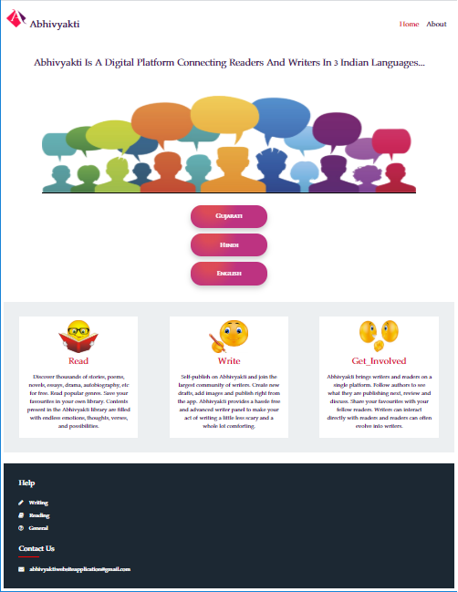

**22**

* 1. **About Us:**



**23**

* 1. **Index Page – 1:**



* 1. **Index Page – 2:**



**24**

* 1. **Index Page – 3:**



* 1. **Google Sign-In – 1:**

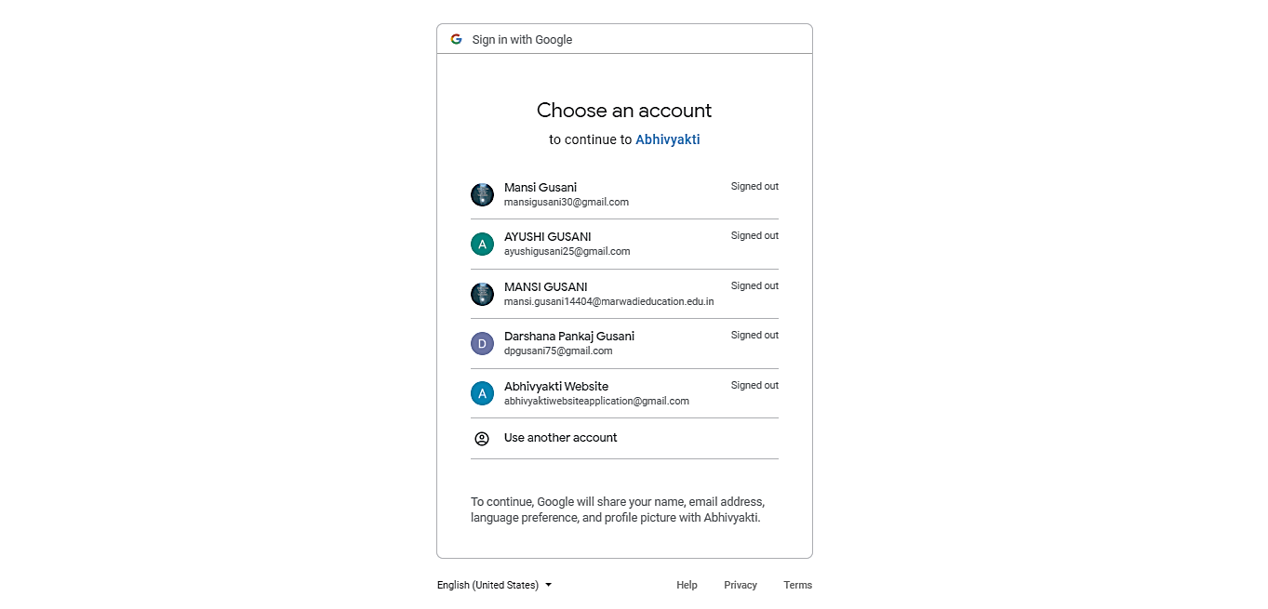

**25**

* 1. **Google Sign-In – 2:**

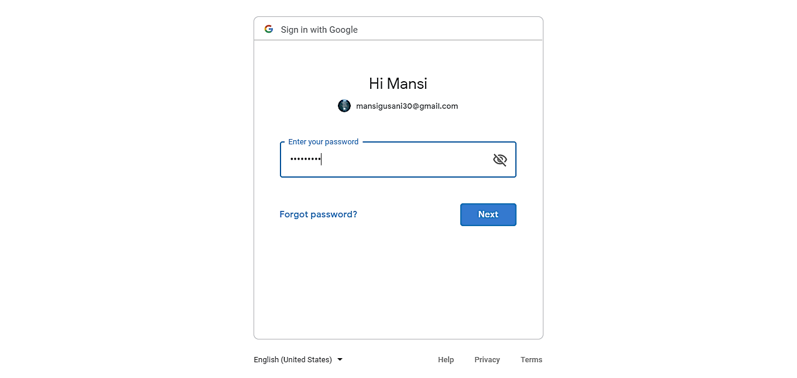

* 1. **Home Page – 1:**



**26**

* 1. **Home Page – 2:**



* 1. **Home Page – 3:**

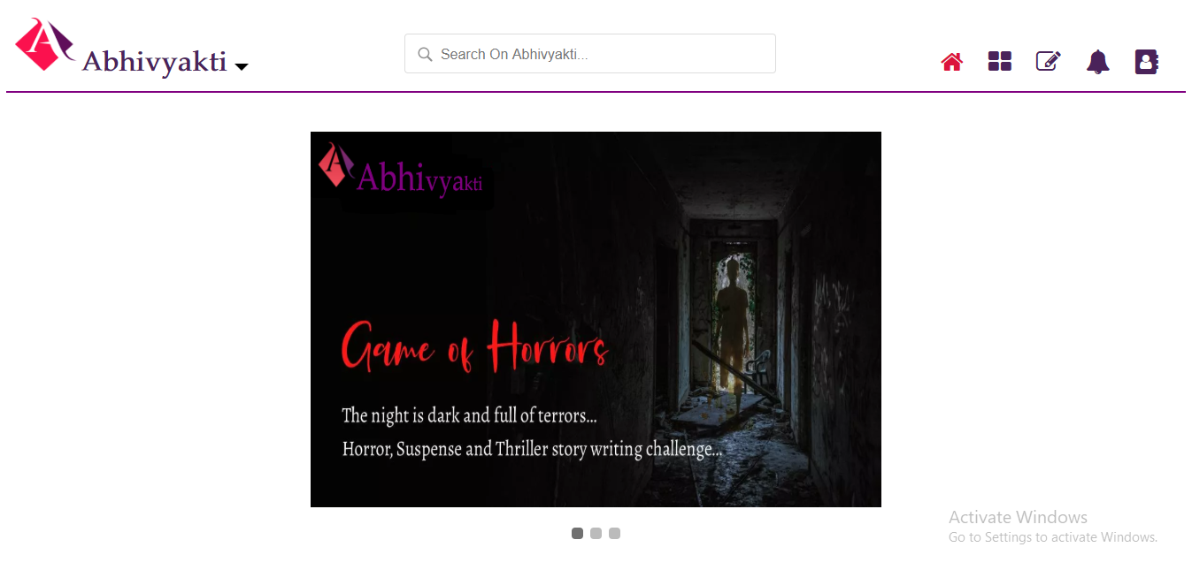

**27**

* 1. **Categories – 1:**



* 1. **Categories – 2:**

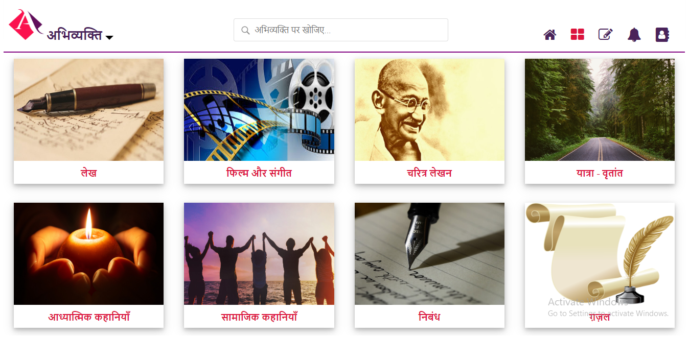

**28**

* 1. **Categories – 3:**



* 1. **Write – 1:**



**29**

* 1. **Write – 2:**



* 1. **Write – 3:**



**30**

* 1. **Update – 1:**

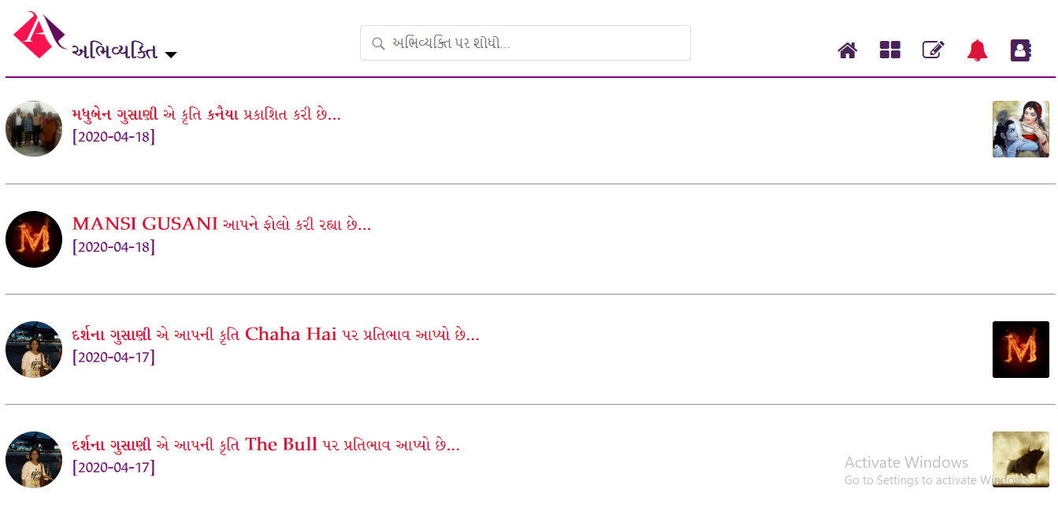

* 1. **Update – 2:**

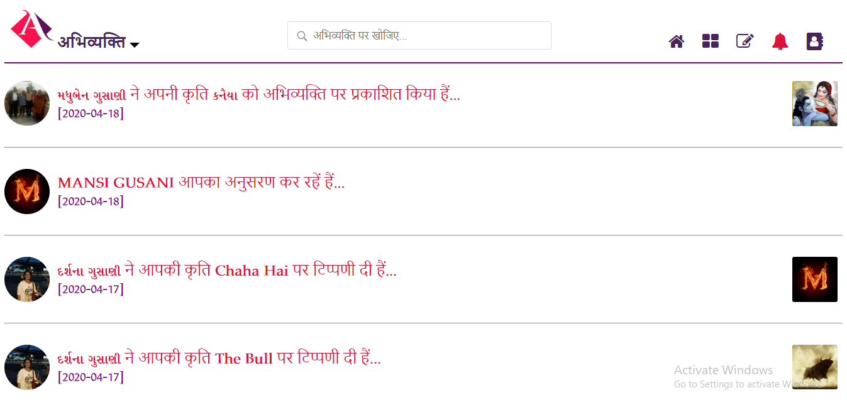

**31**

* 1. **Update – 3:**

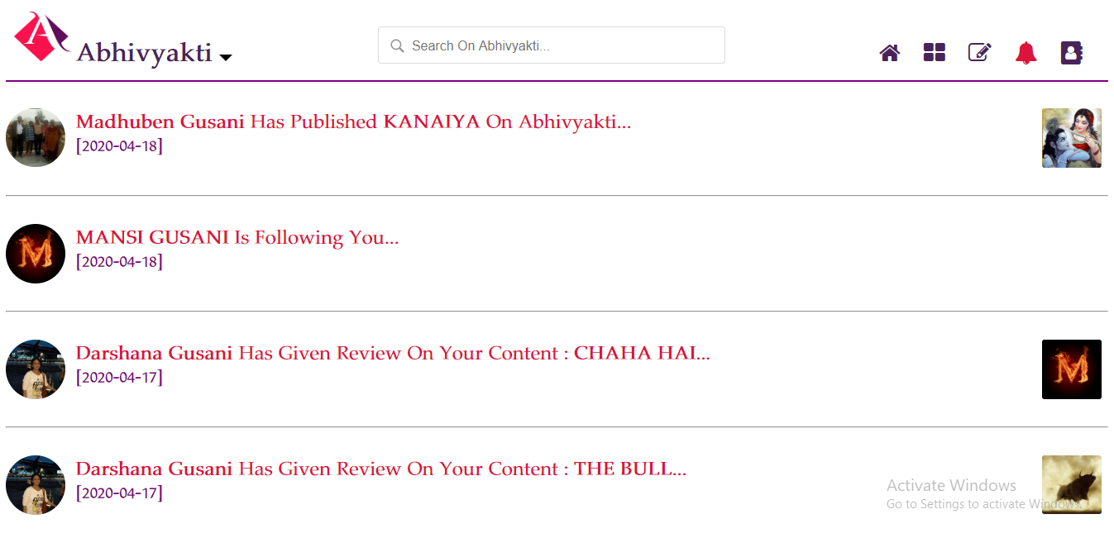

* 1. **User Profile – 1:**

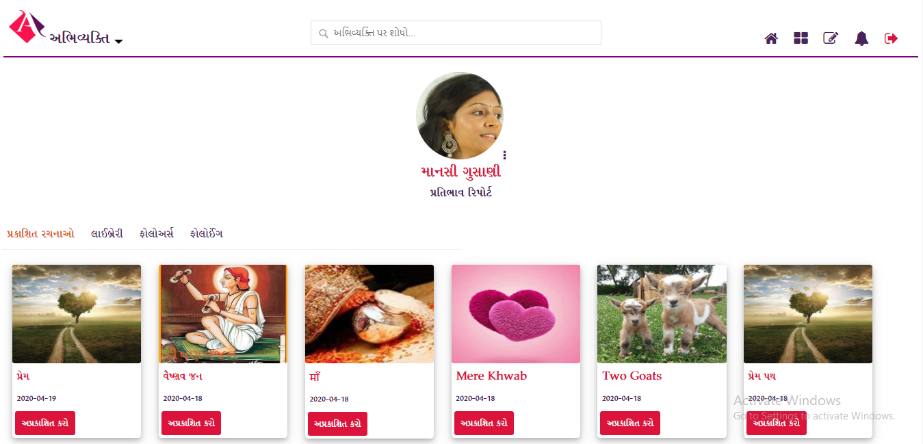

**32**

* 1. **User Profile – 2:**

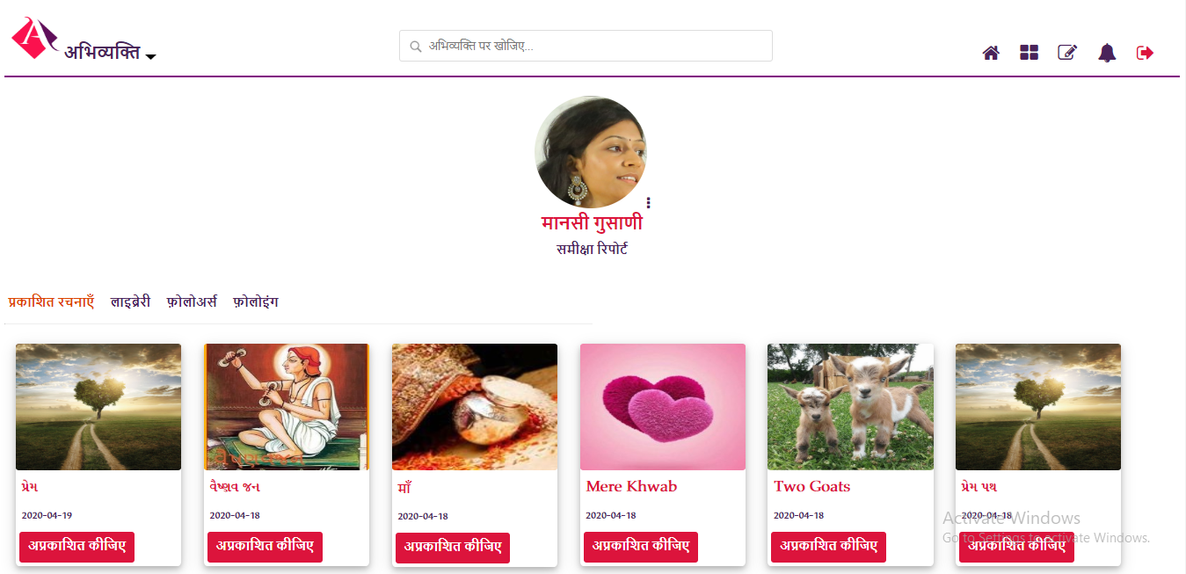

* 1. **User Profile – 3:**

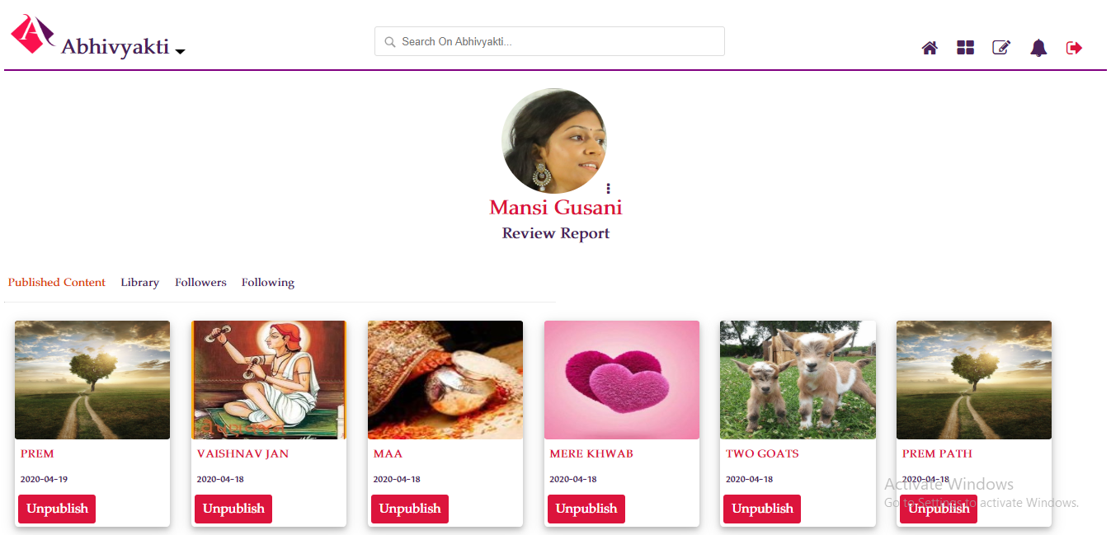

**33**

* 1. **Library – 1:**

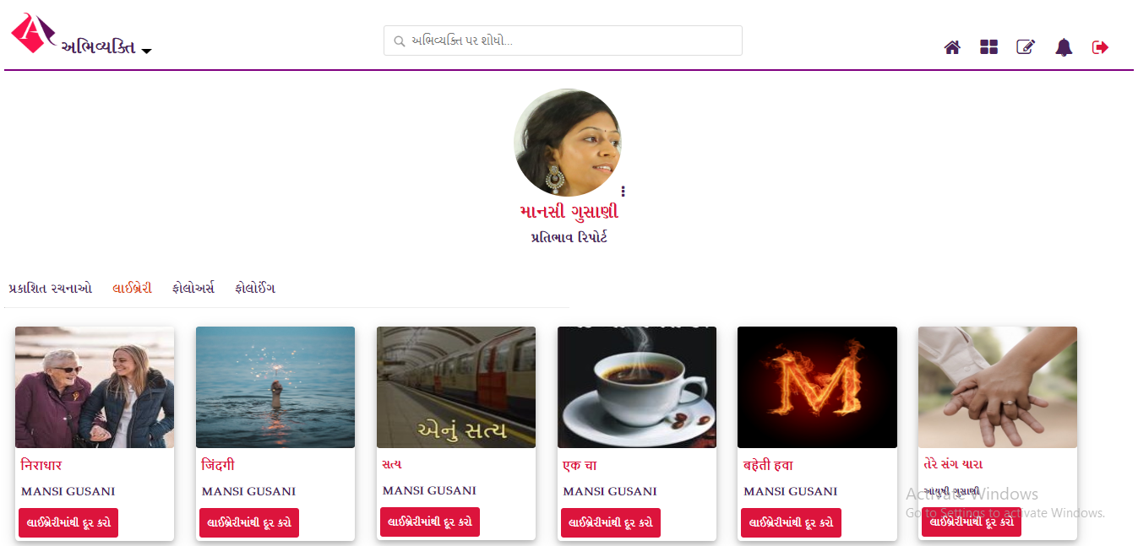

* 1. **Library – 2:**

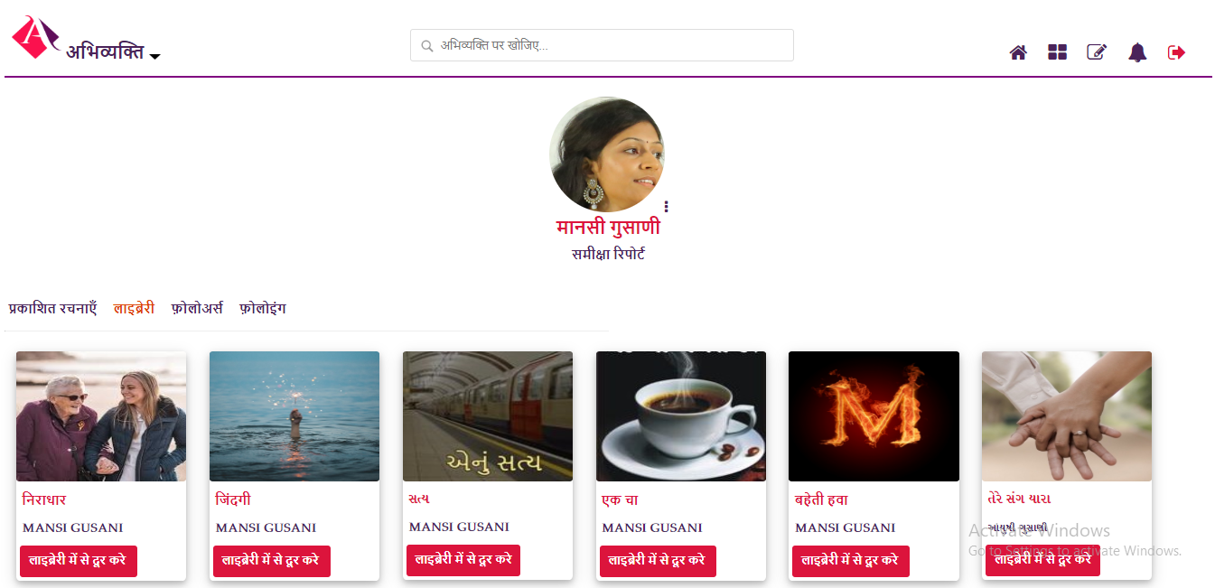

**34**

* 1. **Library – 3:**

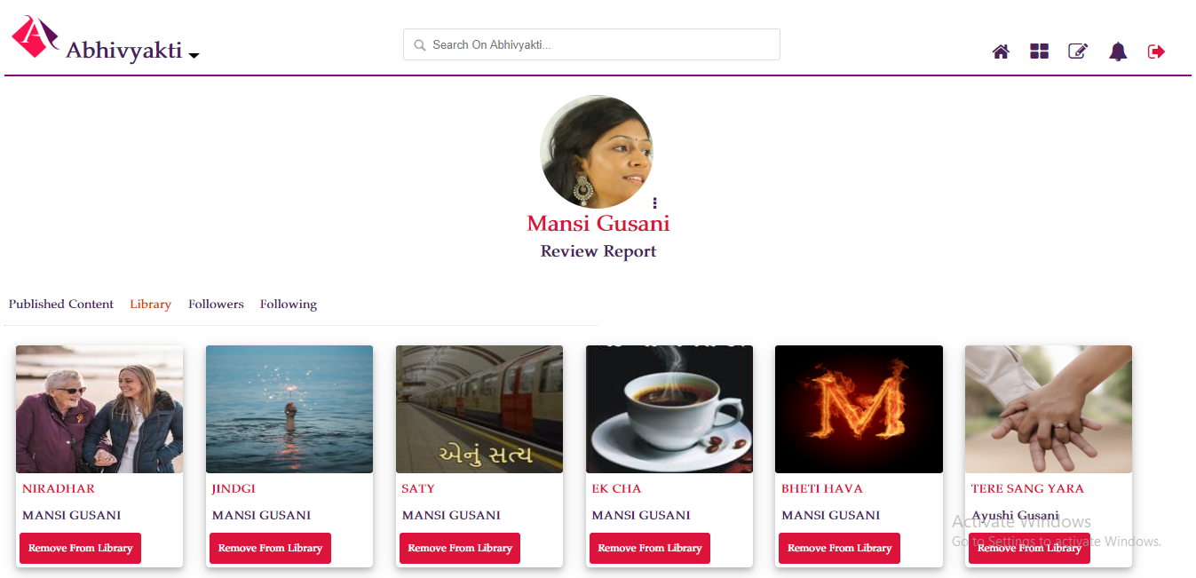

* 1. **Followers – 1:**

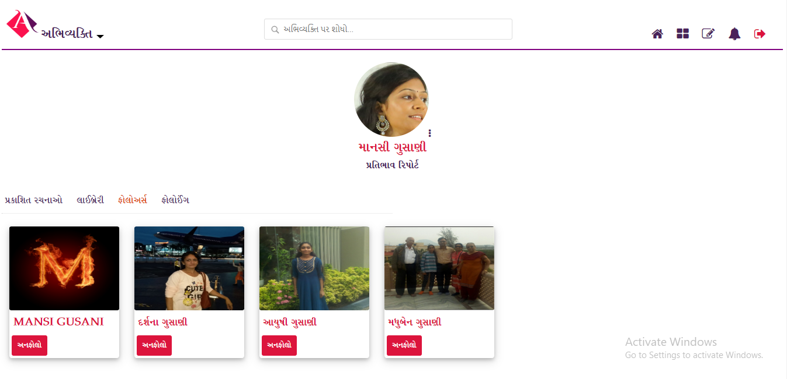

**35**

* 1. **Followers – 2:**

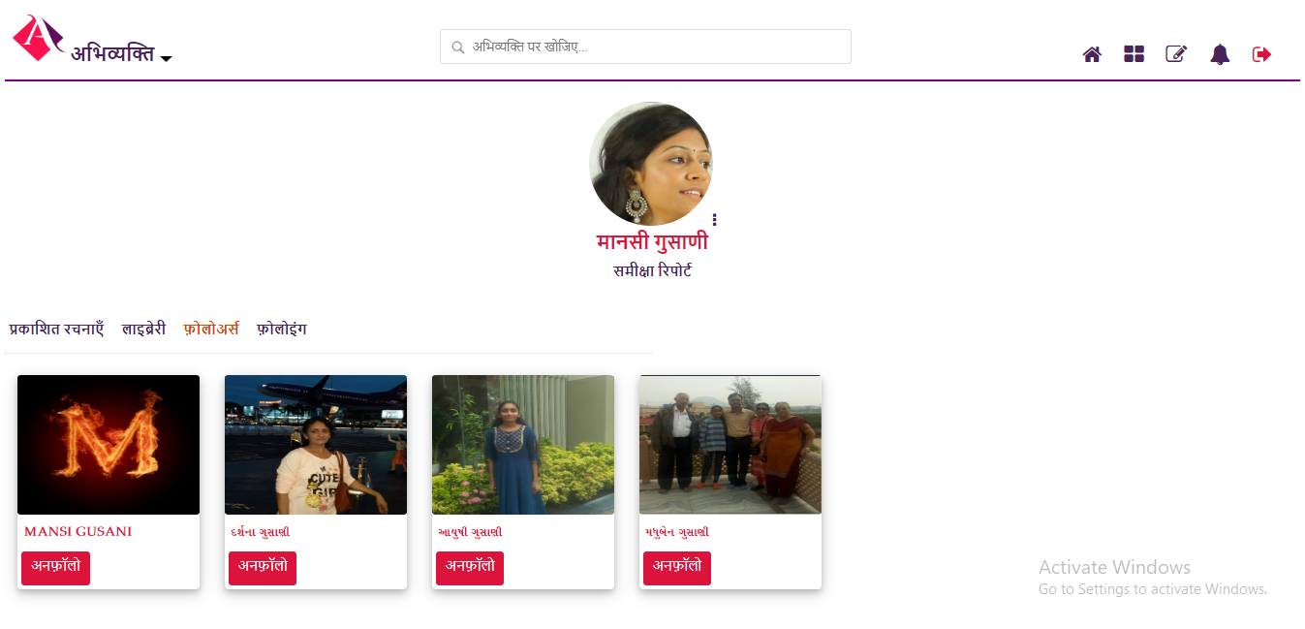

* 1. **Followers – 3:**

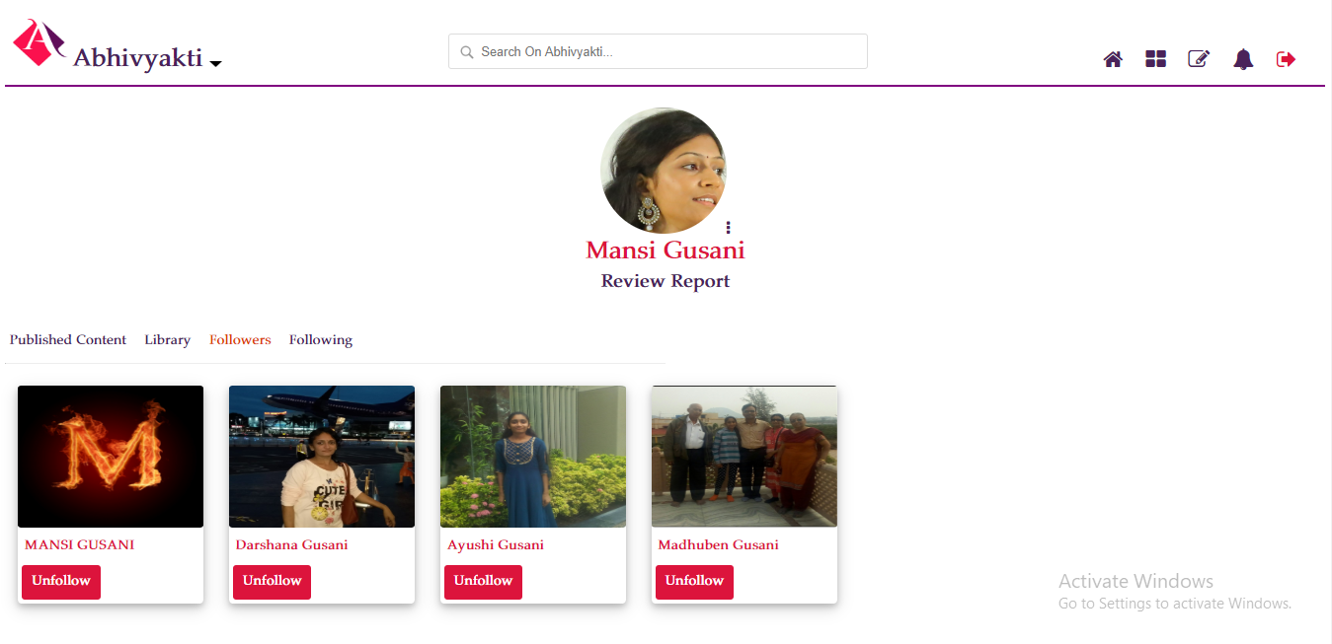

**36**

* 1. **Following – 1:**

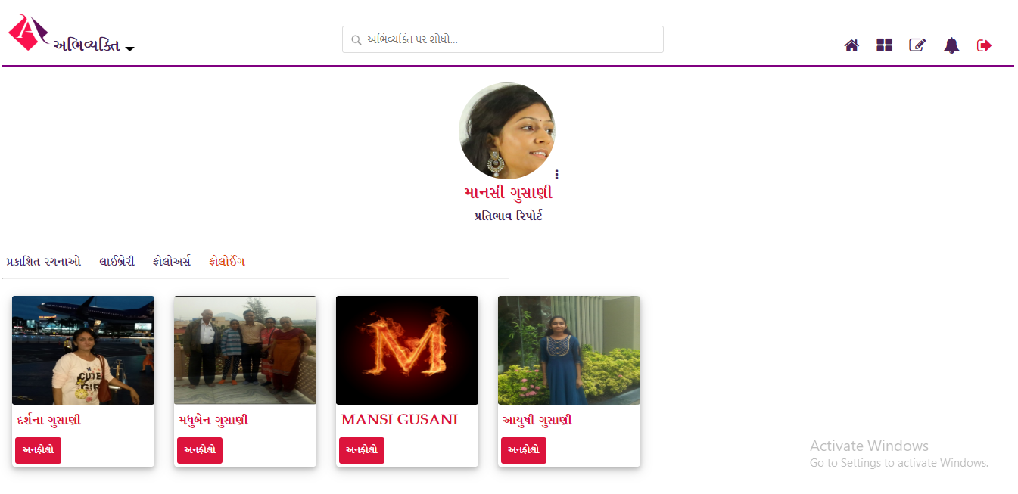

* 1. **Following – 2:**

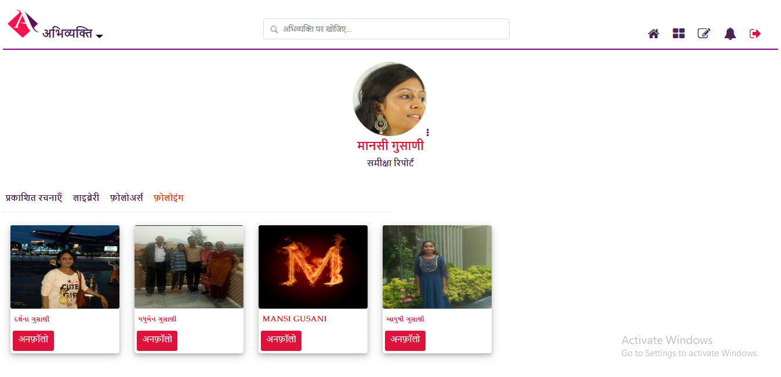

**37**

* 1. **Following – 3:**

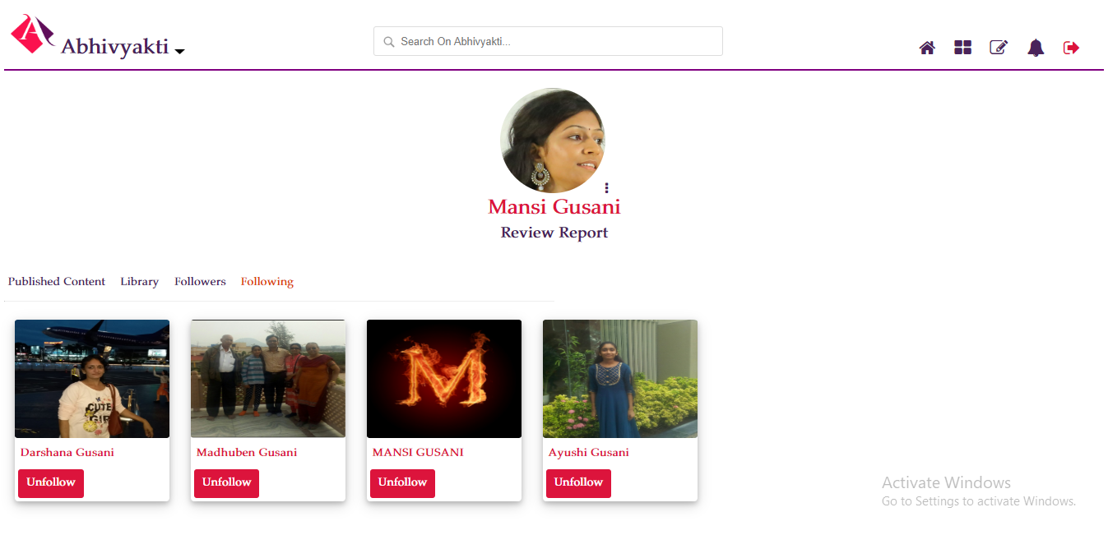

* 1. **Review Report – 1:**

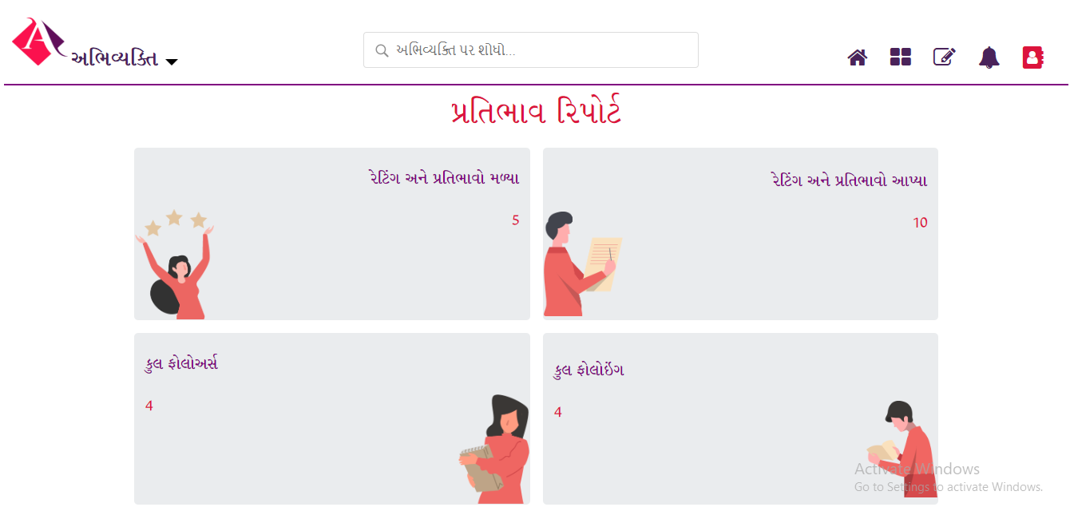

**38**

* 1. **Review Report – 2:**

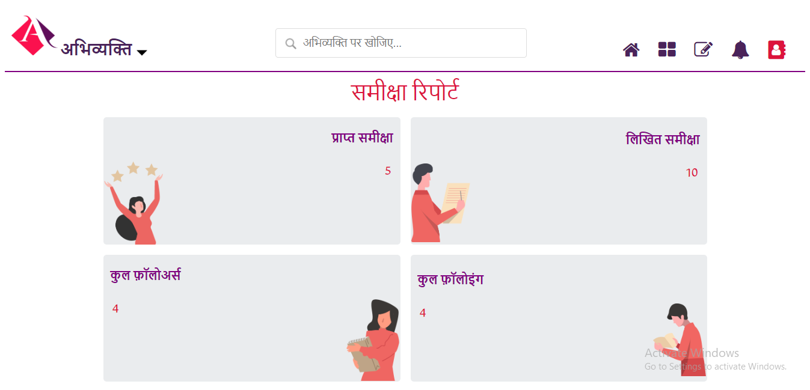

* 1. **Review Report – 3:**

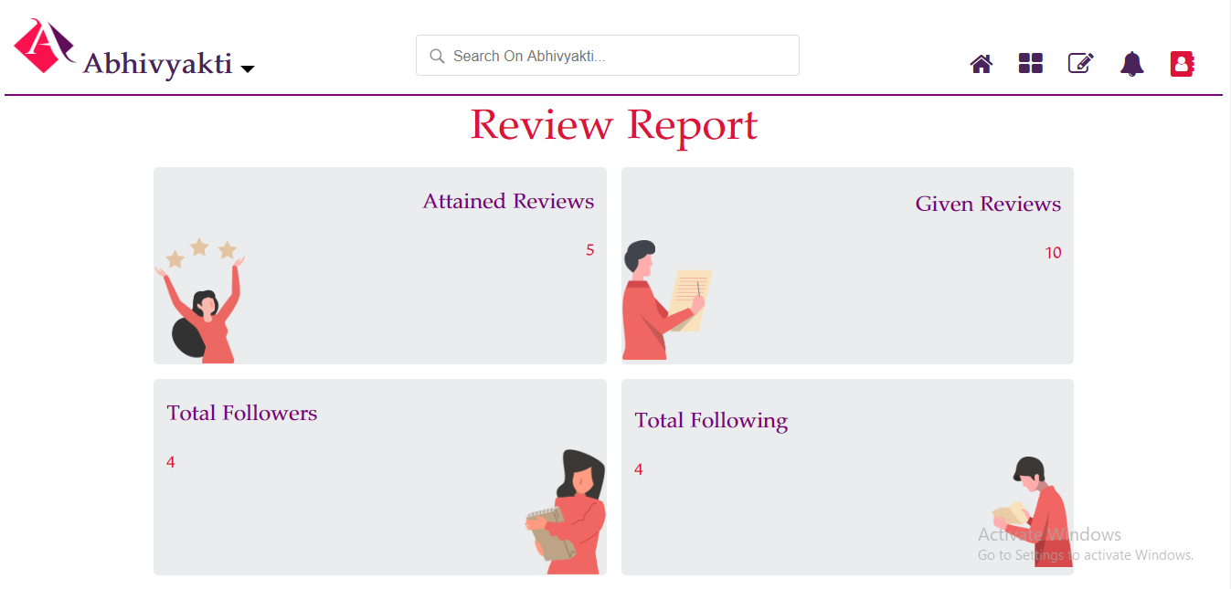

**39**

**Chapter 7**

**SOURCE CODE**

* **database.php:**

<?php

define(‘DB_HOST’, ‘localhost’);

define(‘DB_USERNAME’, ‘root’);

define(‘DB_PASSWORD’, ‘’);

define(‘DB_NAME’, ‘mysql’);

define(‘DB_USER_TBL’, ‘users’);

define(‘GOOGLE_CLIENT_ID’, ‘ ‘);

define(‘GOOGLE_CLIENT_SECRET’, ‘ ‘);

define(‘GOOGLE_REDIRECT_URL’, ‘http://localhost:8000/Pictures’);

require_once ‘google-api-php-client/src/Google_Client.php’;

require_once ‘google-api-php-client/src/contrib/Google_Oauth2Service.php’;

$gClient = new Google_Client();

$gClient->setApplicationName(‘Abhivyakti’);

$gClient->setClientId(GOOGLE_CLIENT_ID);

$gClient->setClientSecret(GOOGLE_CLIENT_SECRET);

$gClient->setRedirectUri(GOOGLE_REDIRECT_URL);

$google_oauthV2 = new Google_Oauth2Service($gClient);

?>

**40**

* **user_class.php:**

<?php

require_once 'database.php';

class User

{

private $dbHost = DB_HOST;

private $dbUsername = DB_USERNAME;

private $dbPassword = DB_PASSWORD;

private $dbName = DB_NAME;

private $userTbl = DB_USER_TBL;

function __construct()

{

if(!isset($this->db))

{

$conn = new mysqli($this->dbHost, $this->dbUsername, $this->dbPassword, $this->dbName);

if($conn->connect_error)

{

die("Failed to connect with MySQL: " . $conn->connect_error);

}

else

{

$this->db = $conn;

}

}

}

function checkUser($userData = array())

{

if(!empty($userData))

**41**

{

$checkQuery = "SELECT * FROM ".$this->userTbl." WHERE oauth_provider = '".$userData['oauth_provider']."' AND oauth_uid = '".$userData['oauth_uid']."'";

$checkResult = $this->db->query($checkQuery);

if($checkResult->num_rows > 0)

{

$query = "UPDATE ".$this->userTbl." SET first_name = '".$userData['first_name']."', last_name = '".$userData['last_name']."', email = '".$userData['email']."', picture = '".$userData['picture']."', modified = NOW() WHERE oauth_provider = '".$userData['oauth_provider']."' AND oauth_uid = '".$userData['oauth_uid']."'";

$update = $this->db->query($query);

}

else

{

$query = "INSERT INTO ".$this->userTbl." SET oauth_provider = '".$userData['oauth_provider']."', oauth_uid = '".$userData['oauth_uid']."', first_name = '".$userData['first_name']."', last_name = '".$userData['last_name']."', email = '".$userData['email']."', picture = '".$userData['picture']."', created = NOW(), modified = NOW()";

$insert = $this->db->query($query);

}

$result = $this->db->query($checkQuery);

$userData = $result->fetch_assoc();

}

return $userData;

}

} ?>

**42**

* **index.php:**

<?php

session_start();

require_once 'database.php';

require_once 'user_class.php';

?>

<?php

if(isset($_GET['code']))

{

$gClient->authenticate($_GET['code']);

$_SESSION['token'] = $gClient->getAccessToken();

header('Location: '. filter_var(REDIRECT_URL_1,FLTER_SANITIZE_URL));

}

if(isset($_SESSION['token']))

$gClient->setAccessToken($_SESSION['token']);

if($gClient->getAccessToken())

{

$gpUserProfile = $google_oauthV2->userinfo->get();

$user = new User();

$gpUserData = array();

$gpUserData['oauth_uid'] = !empty($gpUserProfile['id'])?$gpUserProfile['id']:'';

$gpUserData['first_name'] = !empty($gpUserProfile['given_name'])? strtoupper($gpUserProfile['given_name']):'';

$gpUserData['last_name'] = !empty($gpUserProfile['family_name'])? strtoupper($gpUserProfile['family_name']):'';

$gpUserData['email']=empty($gpUserProfile['email'])?$gpUserProfile['email']:'';

$gpUserData['picture']=!empty($gpUserProfile['picture'])?

**43**

$gpUserProfile['picture']:'';

$gpUserData['oauth_provider'] = 'GOOGLE';

$userData = $user->checkUser($gpUserData);

$_SESSION['userData'] = $userData;

$conn=mysqli_connect("localhost","root","");

$db=mysqli_select_db($conn,"mysql");

$checkResult1=mysqli_query($conn,"select * from profile where oauth_provider = '$userData[oauth_provider]' and oauth_uid = '$userData[oauth_uid]'");

$checkResult2=mysqli_fetch_array($checkResult1,MYSQLI_ASSOC);

if($checkResult2['oauth_provider']==$userData['oauth_provider'] && $checkResult2['oauth_uid']==$userData['oauth_uid'])

{

$result=mysqli_query($conn,"update profile set fname='$userData[first_name]',lname='$userData[last_name]',email='$userData[email]' modified = NOW() where oauth_provider = '$userData[oauth_provider]' and oauth_uid = '$userData[oauth_uid]'");

}

else

{

$result=mysqli_query($conn,"insert into profile (pid,fnameg,fname,lnameg,lname,bdate,email,phone,oauth_provider,oauth_uid,img) values('','$userData[first_name]','$userData[first_name]','$userData[last_name]','$userData[last_name]','','$userData[email]','','$userData[oauth_provider]','$userData[oauth_uid]','')");

}

if(!empty($userData))

{

**44**

header("Location:index1.php");

}

else

{

$output = '<h1 style="color:red"><center><br><br><br>Some Problem Occurred, Please Try Again.</center></h1>';

}

}

else

{

$authUrl = $gClient->createAuthUrl();

$output='<a href="'.filter_var($authUrl, FILTER_SANITIZE_URL).'">Google Sign In / ગૂગલ સાઈન ઈન</a>';

}

?>

<html>

<head>

<meta charset="utf-8">

<meta name="viewport" content="width=device-width,initial-scale=1">

<link rel="stylesheet" href="style.css">

<link rel="stylesheet" href="style1.css">

<link rel="stylesheet" href="random_quotes.css" type="text/css">

<link rel="stylesheet" href="path/to/font-awesome/css/font-awesome.min.css">

<link href="https://fonts.googleapis.com/css?family=Ubuntu" rel="stylesheet">

<script src="show_random_quotes.js"></script>

<script src="https://ajax.googleapis.com/ajax/libs/jquery/3.1.0/jquery.min.js"> </script>

<style>

*{box-sizing: border-box}

**45**

body

{

font-family: Verdana,sans-serif;

}

.mySlides

{

display: none

}

.slideshow-container

{

width: 1200px;

position: relative;

margin: auto;

}

/* The dots/bullets/indicators */

.dot

{

cursor: pointer;

height: 13px;

width: 13px;

margin: 0 2px;

background-color: #dc143c;

border-radius: 30%;

display: inline-block;

transition: background-color 0.6s ease;

}

.active,.dot:hover

{

background-color: purple;

**46**

}

/* Fading animation */

.fade

{

-webkit-animation-name: fade;

-webkit-animation-duration: 2s;

animation-name: fade;

animation-duration: 2s;

}

</style>

</head>

<body background="Feather.jpg">

<center>

<div class="slideshow-container">

<div class="mySlides fade">

<table cellspacing="32">

<tr>

<td>

<img src="Logo_1.jpg">

</td>

<td>

<div class="main">

<table cellspacing="64">

<tr>

<td>

<div class="main1">

<center>

<br><br> <font face="Yamuna" size="7" color="purple">સાઈન ઈન </font><br><br>

**47**

<font face="Yamuna" size="5" color="#dc143c">...આપને ગમતા લેખક અને કવિને ફોલો કરો,</font><br><br>

<font face="Yamuna" size="5" color="purple">પ્રતિભાવ આપો</font><br><br>

<font face="Yamuna" size="5" color="#dc143c">અને</font><br><br>

<font face="Yamuna" size="5" color="purple">પોતાની લાઈબ્રેરી બનાવો...</font>

</center>

</div>

</td>

</tr>

</table>

</div>

</td>

</tr>

</table>

</div>

<div class="mySlides fade">

<table cellspacing="32">

<tr>

<td>

<img src="Logo_2.jpg">

</td>

<td>

<div class="main">

<table cellspacing="64">

<tr>

<td>

**48**

<div class="main1">

<center>

<br><br>

<font face="Yamuna" size="7" color="purple">Sign In</font><br><br><br>

<font face="Yamuna" size="4" color="#dc143c">To Follow Your Favourite Authors And Poet,</font><br><br>

<font face="Yamuna" size="4" color="purple">To Review The Contents</font><br><br>

<font face="Yamuna" size="4" color="#dc143c">And</font><br><br>

<font face="Yamuna" size="4" color="purple">Create Your Own Library...</font>

</center>

</div>

</td>

</tr>

</table>

</div>

</td>

</tr>

</table>

</div>

</div>

<br><br><br><br>

<div>

<span class="dot" onclick="currentSlide(1)"></span>

<span class="dot" onclick="currentSlide(2)"></span>

</div>

<script>

var slideIndex = 0;

**49**

showSlides();

var slides,dots;

function showSlides()

{

var i;

slides = document.getElementsByClassName("mySlides");

dots = document.getElementsByClassName("dot");

for (i = 0; i < slides.length; i++)

{

slides[i].style.display = "none";

}

slideIndex++;

if (slideIndex > slides.length)

{

slideIndex = 1

}

for (i = 0; i < dots.length; i++)

{

dots[i].className = dots[i].className.replace("active","");

}

slides[slideIndex-1].style.display = "block";

dots[slideIndex-1].className += " active";

setTimeout(showSlides, 4000);

}

function currentSlide(index)

{

if (index > slides.length)

{

index = 1

**50**

}

else if(index < 1)

{

index = slides.length

}

for (i = 0; i < slides.length; i++)

{

slides[i].style.display = "none";

}

for (i = 0; i < dots.length; i++)

{

dots[i].className = dots[i].className.replace("active","");

}

slides[index-1].style.display = "block";

dots[index-1].className += " active";

}

</script>

</center>

<br>

<p align="center">

<span class=quote-container>

<span class=quote-body><font face="Yamuna" size="6" color="#dc143c">"ખુશી = વસ્તુઓ ÷ ઇચ્છાઓ"</font></span>

<span class=quote-author><font face="Yamuna" size="6" color="Purple">&nbsp;&nbsp;― જય પરીખ</font></span>

</span>

<span class=quote-container>

<span class=quote-body><font face="Yamuna" size="5" color="#dc143c">"At

**51**

The End Of The Day... All You Need Is Clean Heart & Placid Mind..."</font></span>

<span class=quote-author><font face="Yamuna" size="5" color="Purple">&nbsp;&nbsp;- JAY PARIKH</font></span>

</span>

<span class=quote-container>

<span class=quote-body><font face="Yamuna" size="6" color="#dc143c">"...તારું જો કશુંયે ના હોય તો છોડીને આવ તું, તારું જો બધુંયે હોય તો છોડી બતાવ તું... "</font></span>

<span class=quote-author><font face="Yamuna" size="6" color="Purple">&nbsp;&nbsp;- રાજેશ વ્યાસ, 'મિસ્કીન'</font></span>

</span>

<span class=quote-container>

<span class=quote-body><font face="Yamuna" size="5" color="#dc143c">"Changes Always Negotiating All Over... But Acceptance Is Only The Way..."</font></span>

<span class=quote-author><font face="Yamuna" size="5" color="Purple">&nbsp;&nbsp;- JAY PARIKH</font></span>

</span>

<span class=quote-container>

<span class=quote-body><font face="Yamuna" size="6" color="#dc143c">"કળા એટલે પ્રત્યેક ચીજને, એટલે કે વિચારને, વાણીને, વર્તનને તેના યથાયોગ્ય સ્થાને મૂકવી." </font></span>

<span class=quote-author><font face="Yamuna" size="6" color="Purple">&nbsp;&nbsp;- જે કૃષ્ણમૂર્તિ</font></span>

</span>

<span class=quote-container>

<span class=quote-body><font face="Yamuna" size="5" color="#dc143c">"Be

**52**

The Change, That You Wish To See In The World."</font></span>

<span class=quote-author><font face="Yamuna" size="5" color="Purple">&nbsp;&nbsp;- MAHATMA GANDHIJI</font></span>

</span>

<span class=quote-container>

<span class=quote-body><font face="Yamuna" size="6" color="#dc143c">" મને તમે ઉગારો એવી મારી પ્રાર્થના નથી, પણ હું તરી શકું એટલું બળ મને આપજો. "</font></span>

<span class=quote-author><font face="Yamuna" size="6" color="Purple">&nbsp;&nbsp;- રવિન્દ્રનાથ ટાગોર</font></span>

</span>

<span class=quote-container>

<span class=quote-body><font face="Yamuna" size="5" color="#dc143c">"The Powers Of The Mind Are Like The Rays Of The Sun, When They Are Concentrated; They Illumine."</font></span>

<span class=quote-author><font face="Yamuna" size="4" color="Purple">&nbsp;&nbsp;― SWAMI VIVEKANAND</font></span>

</span>

<span class=quote-container>

<span class=quote-body><font face="Yamuna" size="6" color="#dc143c">" વિચાર ગમે તેટલો જાગૃત અને ઊંચો હોય; પણ જ્યાં સુધી કાર્યાન્વિત ન થાય, ત્યાં સુધી એની કોઈ જ કિંમત નથી ."</font></span>

<span class=quote-author><font face="Yamuna" size="6" color="Purple">&nbsp;&nbsp;- ગાંધીજી</font></span>

</span>

<span class=quote-container>

<span class=quote-body><font face="Yamuna" size="5" color="#dc143c">"Success Is When; Your Signature Becomes Your

**53**

Autograph."</font></span>

<span class=quote-author><font face="Yamuna" size="5" color="Purple">&nbsp;&nbsp;- DR APJ ABDUL KALAM</font></span>

</span>

</p>

<script>

$(function()

{

showRandomQuotes();

})

</script>

<a href="#">

<span></span>

<span></span>

<span></span>

<span></span>

<font color="#FF0099">Google Sign In / ગૂગલ સાઈન ઈન</font>

</a>

<div>

<?php

echo $output;

?>

</div>

</body>

</html>

**54**

**Chapter 8**

**CONCLUSION**

Here by, I declare my Software Project titled “ABHIVYAKTI WEBSITE” complete. I assure to have prepared this project completely by myself without any kind of duplicity and/or copying and material. Hope the efforts put by me is useful.

“I have tried my best for developing this website for user’s convenience and easiness...”

**55**

**Chapter 9**

**BIBLIOGRAPHY**

**9.1 Online References:**

* <https://www.w3schools.com>
* <https://www.w3resource.com>
* https://www.tutorialspoint.com
* <https://www.geeksforgeeks.org>

**9.2 Offline References:**

* PHP And MySQL Web Development – Luke Welling, Laura Thomson – Pearson
* Julie C Meloni, “Sams Teach Yourself PHP, MYSQL And APACHE All In One”, ‘4th’ Edition – Pearson Education

**56**